TABLE OF CONTENTS

CONTENT PAGE
CHAPTER 1 3
INTRODUCTION 3
1.1 Background of the Study 3
1.2 Problem Statement 5
1.3 Research Objective 6
1.4 Research Scope 6
1.5 Research Significance 6
1.6 Chapter Outline 7
CHAPTER 2 8
LITERATURE REVIEW 8
2.1 Overview of Microcontroller 8
2.1.1 Categories of Microcontroller 9
2.1.2 Raspberry Pi board 11
2.1.3 GSM Module 12
2.1.4 SMS Notification 13
2.1.5 Voice Recognition 14
2.1.6 Servo Motor 14
2.2 Door Lock 15
2.2.1 Lock Door Status 15
2.3 Related Work 16
2.3.1 An Electronic Lock for Secured System 16
2.3.3 Raspberry Pi Home Automation Using Android Application 17
2.4 Summary 19
CHAPTER 3 20
METHODOLOGY 20
3.1 Initiation Phase 20
3.2 Planning Phase 21
3.2.1 Hardware Requirement 21
3.2.2 Proposed Architecture 24
3.2.3 Software Requirement 24
3.2.4 Design Specification 25
3.2.5 Test Cases 27
3.3 Development Phase 28
3.4 Evaluation Phase 28
3.5 Documentation Phase 28
3.6 Summary 34
REFERENCES 35

CHAPTER 1

INTRODUCTION

This chapter briefly explains the overall idea of the project. This chapter consists of the introduction of the focus area, objective, scope and significance of the project.

1.1 Background of the Study

Security is important in our daily life because the purpose of security is to give protection to a person, construction, society, or country against threats. With the security in microcontroller, it will ensure privacy and data from being stolen in the fast growing digital world right now. Security is also being made into embedded applications at all levels, including hardware.
As mentioned above, security is needed at every place and at all time. At UiTM Perlis, the current door lock system at prohibited room is still using padlocks and knob locks key that can be easily broken in. Sometimes, the negligence happens when the staff or security staff forgot to lock up the door. The result of such negligence causes the property and data to be easily stolen.
In motor vehicles, home appliances, mobiles, office machines and many more. There is a compact microcomputer that is intended to manage the operation of embedded systems which called microcontroller. Microcontroller usually has a memory, processor and peripheral functions such as analog-to-signal converters, liquid crystal display (LCD) controller, timers and universal serial bus (USB). This microcontroller is usually implemented with specialized parts that are helpful in embedded system such as serial port, on-board memory, networking, audio and analog I/O. It makes life pretty easy in the present world and it is possible to raise efficiency or safety, or any features. The microcontroller is like a brain where it takes in electrical signal, and makes decisions based on those signals as stated by Dahl Nydal (2014).
Many features have been made which corporate with a microcontroller such as biometric. This technology is mainly used for credentials and access control, or for identifying individuals who are under surveillance. According to Lindasalwa Muda (2010), it is consists of the process to translate a speech waveform into features that are useful for further processing. This project will be using voice recognition is part of bio metric’s features. Voice recognition is a system in computing technology by which dedicated software and systems that are created to identify, distinguish and authenticate the voice of an individual speaker. Voice recognition is linked to speech recognition systems but the former only identifies the speaker whereas the latter can understand and evaluate what has been said.
This project is about proposing a door lock system with voice recognition. It will perform in any valuable room that stores precious and important items such as server room. The domain of this project are security, microcontroller, voice recognition, GSM module. The door lock system can be controlled by the staff who guard the room using their voice to lock the door. It will give an efficient and accurate response when there is a communication between the microcontroller and the voice recognition system.

1.2 Problem Statement

In this sophisticated era, all the important information will be kept in a place that needs to be protected from being infringed by several parties who can cause damage and theft. This is due to the weakness of the entry door to the prohibited area that stores exam papers and many more. Most of the locks installed at the rooms are with the usual keypad or padlocks for opening the doors. Therefore, the existing doors, for now, need to constantly update the door lock security because criminals like shoulder surfing and are trying to bypass the security lock. With this incident, it can cause the loss for any party due to the break-in resulting from theft.
With the help of police or security guards which is currently used by any organization or party, it is still insufficient to safeguard and patrol every area that needs to be guarded. As a human, carelessness can still happen such as forgetting to lock up, overlooking when the thief enters the room or setting up low-quality padlocks. So, potentially property or data loss outcome will occur due to the lack of security door locks system. This is a property crime which involves the taking of someone else's property without the use of force or the threat of force by Truthfinder (2017).
To enhance the security and defensive system, the current door lock system at the prohibited rooms in UiTM Perlis needs to be updated. The system needs to identify the keyword from a voice to unlock the door latch. This voice system can be controlled by a security guard and after using it, it will receive a notification that triggers after the door lock has been opened. Therefore, this project proposes a door lock system with voice recognition and to test the functionality performance that will improve the security and to update the door lock system at prohibited rooms.

1.3 Research Objective

The main objective of this project research are:
- To develop the security and defensive system by using Raspberry Pi at UiTM Perlis prohibited rooms.
- To evaluate the result of the system based on performance and functionality test.

1.4 Research Scope

This project will be a limited use in UiTM Perlis campus by The Security Department. The staff or security guards will use this project to control the open door lock system to enter to lock up the door where it will be implemented at the prohibited room such as the server rooms and exam papers rooms.

1.5 Research Significance

Significance to the research domain, by developing this project, the researcher can do a research on the level of performance of the network that will be implemented by this project which is the GSM module make connection between microcontrollers. The researcher also can learned to set up and make a program to the microcontroller. The significance of this project to the users is UiTM IT staff and UiTM security officers. IT staff and security officer can make sure that door-to-door security can be maintained even though it is not there any closer. As for UiTM, this will help to reduce the risk of losing equipment and prevent attackers from attacking the server and stealing exam papers.

1.6 Chapter Outline

This chapter, focuses on the introduction of the project, focus area, scope and significance. For chapter 2 is about literature review of the project title. This chapter will provide the information related to the project in order to understand the scope of the research project. Then, chapter 3 will briefly discuss on the implementation process of this project.

CHAPTER 2

LITERATURE REVIEW

This chapter will focus on the information related to the project in order to improve the understanding of the scope of this research project. Literature review has been done and all information are taken from journals, theses, and books that are related to this project

2.1 Overview of Microcontroller

A microcontroller can be defined as single integrated circuit or chip that perform specific operations. It contains a memory, microprocessor and peripheral devices such as input-output ports, timers, universal serial bus and other special function sub-system located. A microcontroller is kind of like a brain where it takes in electrical signal, and makes decisions based on those signals that stated by Dahl Nydal (2014). Most microcontrollers are single- chip-integrated system and have the ability to control program and data memory and input-output ports. Besides that, according to John A. Chandy (2008), a microcontroller typically will collaborate with other specific components that are useful in embedded systems such as serial ports, networking, onboard memory, audio, and analog I/O. Then, microcontroller also integrated into many appliances such as household, telecommunication, automotive industry, aerospace and many more that stated by Bettina W. (2007). According to Rajput A., a microcontroller is a gadget that is utilized to control a few methodologies or part of a domain. A microcontroller is a profoundly coordinated programmable chip which is preferably suited for control applications. The main reason that has driven the development of microcontroller are versatility, ease to program, and small in size. Then, the microcontroller also has several sections which typical of each type or version of the microcontroller. Figure 2.0 show the components of microcontroller taken from www.mikroe.com.
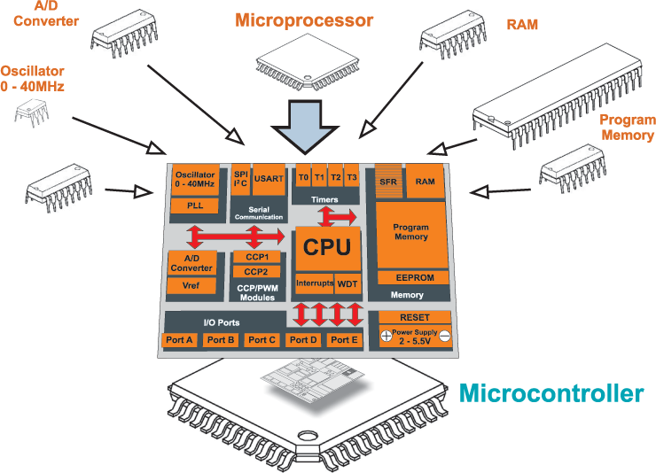
Figure 2.0 Components of A Microcontroller

2.1.1 Categories of Microcontroller

There are many types and versions of a microcontroller which can be categorized based on their bits, memory, memory architecture and instruction sets.

a. Bits

A microcontroller can operate in different bits such as 8 bits, 16 bits, and 32 bits. 8031 and 8051 microcontrollers are examples of a microcontrollers type that used 8 bits microcontroller that perform logic and arithmetic operations. Next, 8096 microcontroller performs with greater accuracy and performance which is 16 bits compared than 8 bits. Then, 32 bits is also use widely used in automatically controlled appliances such as implantable medical appliances, office machine, engine control systems, remote controls, power tools, toys and many more which require the microcontroller to carry out any logical or arithmetic function.

b. Memory
A microcontroller has two types of memory, which are the external memory and embedded memory microcontroller. Embedded Memory Microcontroller is when an embedded structure is built with the microcontroller having all functioning blocks on a chip. One example of this chip is 8051 microcontroller that has embedded memory microcontroller. An external memory controller is memory is not originally built in the blocks existing on a chip such as 8031 microcontrollers.

c. Memory architecture

There are two types of memory architecture which are Harvard Memory Architecture Microcontroller and The Princeton Memory Architecture Microcontroller.

d. Instruction Set

An instruction set is a group of command for the processor in machine language. There are two types of instruction set which are Complex Instruction Set Computer (CISC) and Reduced Instruction Set Computer (RISC). For CISC, it allows the user to put on one instruction as a choice too much simple instruction. Meanwhile, RISC is used to reduce the operation by shortening the clock cycle per instruction. Most microcontrollers use RISC while for CISC is used a lot on a microcontroller for computer's x86.

2.1.2 Raspberry Pi board

There are many types of the microcontroller board such as Arduino, Raspberry, BeagleBone and many more. This project propose to using a Raspberry Pi because this board is provide graphical user interface and can be used like a desktop computer that stated by (Sheikh Ferdoush,2014). It also supports a number of operating systems including a Debian-based Linux which is used in the development of this project.
Raspberry Pi is a series of small single-board computers which is developed by Raspberry Pi Foundation in the United Kingdom. Several generations of Raspberry Pi have been developed to promote the teaching of basic computer sciences. Raspberry Pi microcontroller can be powered by using micro USB connection or external power supply such as batteries and an adapter. Raspbian, a Debian-based Linux operating system is recommended to be used in Raspberry Pi board which is installed on a MicroSD, MiniSD or SD card, depending on the board and available adapters.
There are several pins and connectors on the surface of Raspberry Pi that can be attached to other peripherals. For example, Raspberry Pi 1 Models A+ and B+, Pi 2 Model B, Pi 3 Model B and B+, and Pi Zero and Zero W GPIO J8 have a 40-pin pinout. Raspberry Pi 1 Models A and B have only the first 26 pins. So, a variety of collaborated functions can be implemented and reflect the action according to as programmed.
Table 2.0 The Difference Features of Every Board
BOARD | FEATURES
Arduino | - Processor: AM335x 1GHz ARM Cortex-A8  - 512MB DDR3 RAM  - 2GB 8-bit eMMC on-board flash storage  - NEON floating-point accelerator  - 2x PRU 32-bit microcontrollers  - 3Dgraphics accelerator
Raspberry Pi  (recently Pi 3) | - Processor: AM335x 1GHz ARM Cortex-A8  - 512MB DDR3 RAM  - 2GB 8-bit eMMC on-board flash storage  - NEON floating-point accelerator  - 2x PRU 32-bit microcontrollers  - 3Dgraphics accelerator
BeagleBone | - Processor: AM335x 1GHz ARM Cortex-A8  - 512MB DDR3 RAM  - 2GB 8-bit eMMC on-board flash storage  - NEON floating-point accelerator  - 2x PRU 32-bit microcontrollers  - 3Dgraphics accelerator

2.1.3 GSM Module

Raspberry Pi can be attach with anything peripherals module such as wireless adapter, microphone module, sensor, timer and many more. One peripherals that will be use in this project is GSM module that will trigger the notification to the users.
GSM module is a modem for mobile communication that stands for global system for mobile communication (GSM). Time division multiple access (TDMA) technique is used for communication purposes to develop GSM module. TDMA can easily adapt to data transmission and voice communication and can carry 64kbps to 120Mbps of data rate. There are three components for GSM network. There are a mobile station, base station subsystem and network subsystem. In Raspberry Pi GSM module, it used to plug and play, and can be accessed via UART for GSM mobile network access. Figure 2.1 show the examples of GSM module in Raspberry Pi.

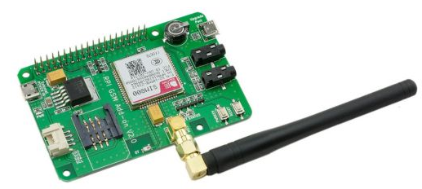
Figure 1.1 GSM Module for Raspberry Pi

2.1.4 SMS Notification

Every peripherals module have their own features that provide the functions of that system. Then, SMS notification is one of the features when using the GSM module which will implement in this project. According to Abhishek S. Parab (2015), GSM chip gets active and send SMS on the phone number which is declared in the piece of code embedded in microcontroller.
SMS is the short form of Short Message Service that use for text messaging service components of most mobile phone. Standard communication protocol is used that enable mobile devices to exchange short text messages. According to the Jeff Brown (2007), SMS messages are handled via a short message service center that the cellular provider maintains for the end devices. Typically, SMS applications can be differentiate such as consumer applications, corporate application and cell operator application.

2.1.5 Voice Recognition

There are many programs or software that can be attached to the features in Raspberry Pi to make it more effective and productive. One of the programs that will be used in this project is voice recognition.
Voice recognition is a program or software that have ability to interpret the human voice. It is commonly used to control a device, execute commands, or write without having to use a keyboard, mouse, or press any buttons. According to Lindasalwa Muda (2010), consist of the process to translate a speech waveform into features that are useful for further processing. It depends on features capability to detention time frequency and energy into set of coefficients for cepstrum analysis. Speech recognition on a terminal is restricted to relatively small vocabularies due ti limitations in processing and power consumption, but it is not affected by communication conditions such as delay or being out of range that stated by Shinya Lizuka (2012).

2.1.6 Servo Motor

Another peripheral of microcontroller that will be used is servo motor. It is rotary actuator or motor that can control in terms of angular position, acceleration and velocity. According to Sheng M. Y. (2016), its drives generally consist of current, velocity, and position control loops. Servo motor require appropriate control loop tuning for commissioning and regular operations that maintain a consistent dynamic response. Servo motor is paired with specific encoder. The Proportional-Integral-Derivative (PID) controller has been used because of its simplicity and more efficience that stated by Kelvinder Singh (2015).

2.2 Door Lock

Every place needs a security when you enter at the place that include entrance. So, door lock is one of the security devices used to secure a door, drawer, lid, gate or a situation when is closed, consisting of a bolt or system of bolts driven and withdrawn by a mechanism operated by a key, dial, keypad and so on.
According to Philip C. D. (2016)., a lock assembly may include a lock switchable between locked and unlocked positions, a door position sensor, interior and exterior directional antennas, lock wireless communications circuitry coupled to the interior and exterior directional antennas, a touch sensor, and a lock controller. A door lock mechanism is disclosed that includes door lock and alarm features that stated by Timothy Noonan (2016). The mechanism includes a controller and a sensor used to detect motions that are representative of attempted access through a door to which the door lock mechanism is attached.

2.2.1 Lock Door Status

There are several condition or status of the lock door such as locked and unlock.
a. Locked

Locked door is a condition where a door cannot be opened barely without the help of a key or something to open it. It was because the door is locked by the special lock that is installed inside the door during construction or using external lockers such as padlock and keypad. In order, to determine the door is locked or not, a person cannot pull or push the door and cannot to twist the doorknob.
b. Unlock

For unlocked condition, it means that the object can be accessed and can get through over it. Unlocked door means a condition where are the door is available to open without using a key or impediment of any object. The door can be pushed or pulled in order to enter a place that involves the existence of a door that has a key.

2.3 Related Work

These are a few studies and projects which are similar or have something in common with to this project. All these studies are described as follows:

2.3.1 An Electronic Lock for Secured System

In this project, the author has stated that there is a necessity to provide the safe access to the personal rooms, lockers and avoid intruders has compelled to make security systems more digitally compatible. Sometimes, it becomes tedious to carry a physical key in case of multiple users that stated by Advait Churi (2016). End up to using an electronic lock door to prohibited room rather than a using physical key.
Previous traditional locking system, used a physical key to unlock any locker or door. The traditional system fails many times for the following cases such as if we forget the key outside ,or there is only one key to be used by many people and on a persons may misuse it. As the key is physical and made up of metal, metal erosion may happen. There are many unauthenticated ways to make duplicate keys in the market. Another instance is, if the key is lost, there will be an inconvenience when opening the lock. We always find it difficult to open lockers and doors without a key.
The alternative for such a problem statement can be some unique authentication like password or biometric which is to be entered at the door of the locker or room. It would be contented to have a digital authentication to unlock your locker so that there is no need to bring keys physically. Even if the user does not have the key, a precise code entered by him or her will open the lock. Electronic Security system provides a multi-user password to be entered to unlock the door. The lock will open only if the entered password matches the saved password in the databases in the system. Wrong passwords will not unlock the door and thus intruders will be kept away.

2.3.3 Raspberry Pi Home Automation Using Android Application

In this project, the author state that it primarily concerned with the programmed control through Android or application as communication protocol interfaces and Raspberry Pi will be processing unit by Himani S. (2017). Therefore, some implementation will be used and Android will be replace with microphone for voice recognition.
Home Automation is needed to be without new wiring and to be very easy installation. Field of home appliance network is still young, many initiatives and standardization efforts have already been made. This new kind of system brought the android application and raspberry-pi into home automation implementation. The proposed system architecture generally incorporates a raspberry pi computer for the purposes of network management and provision of remote access. It can be configured according to our home system.
The user will communicate to raspberry-pi through the Internet via Wi-Fi network. This system is flexible and scalable, allowing additional home appliances designed by multiple vendors, to be securely and safely added to the home network with the minimum amount of efforts. The Wi-Fi network must be having adequate strength also. We can use a Wi-Fi-modem for steeping a Wi-Fi. The serial data coming from Wi-Fi is connected to the raspberry-pi circuit. The main part of the home automation system consists of raspberry-pi board. The user can have an Android interface for using the system. It can be seen as a mini computer capable of doing many functions. The raspberry-pi board is configured for each home appliances. So according to the user intervention they can control over relay circuitry by the user interface which turns the pin command corresponding to relay switches on and device start function. The system is scalable and allows multi-vendor appliances to be added with no major changes to it

2.4 Summary

In summary, literature review is an important chapter that illustrates the idea of what the project is all about. In this chapter discuss on the important component for developing the Door Lock System with Voice Recognition. The important component of this project is the microcontroller. According to the Warren S. Snyder (2017), microcontroller effectuate a wide range of applications in modem electronic installations into which it is functionally integrated. Furthermore, the main project element is voice recognition. Voice recognition is a feature of the microcontroller that will be used to control the door lock and conclude the status of lock door. Collaboration between microcontroller and voice recognition will be made to provide the better work flow with efficient output. In addition, a general definition of door lock has been inserted in this chapter to clarify the term of door lock control system in this project. In this chapter, the related projects which have the objectives to make security and defensive system were also reviewed.

CHAPTER 3

METHODOLOGY

This chapter will briefly discuss the development process of the project. Furthermore, it will was also tell on how to gather information and analyze the data. Choosing the right method for developing this project is necessary because it will determine the success of the objective of this project.
The research will be conducted in multiple phases. There are five phases which are initiation phase, planning phase, development phase, evaluation phase and documentation phase.

3.1 Initiation Phase

In initiation phase, every topic that is related to this project will be gathered and student to gain more knowledge about the project such as on microcontroller, voice recognition technology, Raspberry Pi, and servo motor devices which will be used in this project. All these information are gathered by searching and reviewing the articles, journal and theses from library database, book and websites.
All information that gathered are related to this project to identify the problem statement, objective, scope, limitation and significance. Then, the information are compressed as literature review. The literature review is an important part of guidance to complete the project and to carry on to the next phase.

3.2 Planning Phase

Planning phase is the second phase in methodology where the activities are conducted based on the first phase which is the initiation phase where the initial and information gathered. Then, to conduct the research, an appropriate plan has been made.
Listing of the hardware and software will be been done as preparation. Besides, there are also evaluation method will be used to determine the successful of this project. The results of this project will be used to produce a methodology for this research project.

3.2.1 Hardware Requirement

There are hardware requirement needed for this project as in Table 3.1.
Table 3.1: Hardware requirement for this project
Hardware List | Details
1. Raspberry Pi 2 | The specification of Raspberry Pi 2 board are:  System on chip – Broadcom BCM2836  Processor – 900 MHZ quad-core ARM Cortex A7  GPU – Broadcom VideoCore IV @ 250 MHz  USB port – 4  Memory – 1 GB  I/O pins – 17 GPIO and HAT ID bus  Power source – 5 V via MicroUSB or GPIO header  Storage – MicroSD  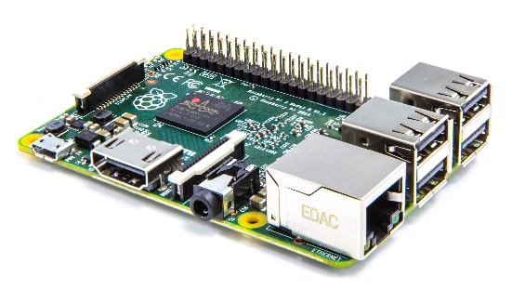  Figure 3.1 Raspberry Pi 2 board
2. Microphone | Microphone will be. It will be attached to the Raspberry Pi 2. The function is to catch the voice from the user to identify authentication of the user based on the keywords from the voice.
3. Servo Motor | Servo motor will be attached to Raspberry Pi 2 and will be connected to door latch to control the two condition which is open and lock. Servo motor that will be used is TowerPro SG90 Servo.  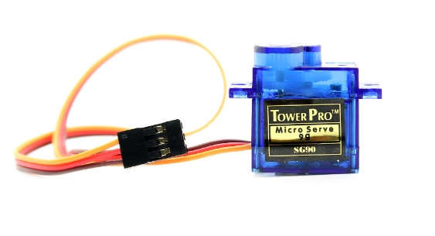  Figure 3.2 TowerPro SG90
4. Power Source | Power sources is used to supply electricity to the system. This project will be using a 5V charger as a power supply to the board and other components.
5. GSM Module | GSM module that will be used is Raspberry PI SIM800 GSM/GPRS. The specification of the GSM module is:  Quad-Band 850/900/1800/1900 MHz  GPRS multislot class 12  Operation level – Digital 3.3V DC  Interface – UART  Speaker and Mic – output and input  Power Source – 5V via Micro USB  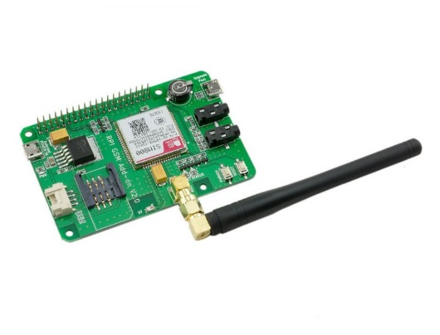  Figure 3.3 GSM Module SIM800
LCD Keypad Shield Display | LCD keypad shield will be used to display door authentication status. It is customized for Raspberry Pi interfaces based on LCD1602 display module. It can also be used to control the contents to be displayed.  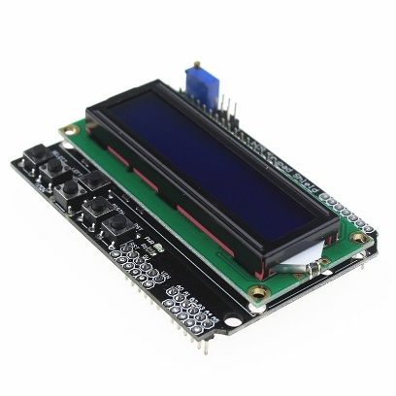  Figure 3.4 LCD Keypad Shield

3.2.2 Proposed Architecture

In Figure 3.5 below show the architecture of this project that will be implement. This system will start where the user speak on microphone. Then, voice input will go through to Raspberry Pi board for authentication. If the authentication is true, Raspberry Pi will sent the output for GSM module to send a message to user such as security staff and servo motor will unlock the door latch.

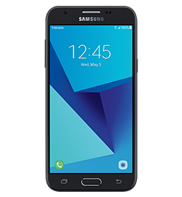

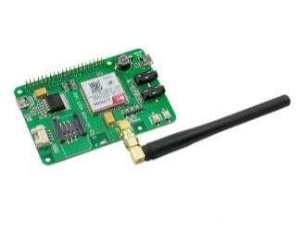

Mobile Phone
GSM Module


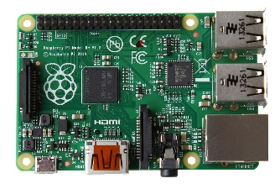
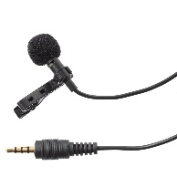


Microphone
Door Latch
Servo motor
Raspberry Pi board

Figure 3.5 Architecture of this the Project

3.2.3 Software Requirement

There are several kinds of software that will be used for this research project. The software requirements for this project are as listed in Table 3.2.
Table 3.2: Software Requirement List
Software List | Details
Python IDE | Python is a platform for programming language that will be used to code this system. All instruction code will be write in python. It also contains a text editor, message area, text console, toolbars and menus.  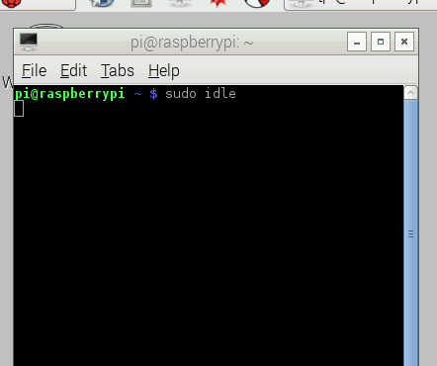  Figure 3.6 The interface of the Python IDE
Raspbian OS | Operating system that will be used is Raspbian where it is a Debian-based computer operating system which is installed in Raspberry Pi.
Raspberry Pi Language Programming | This system will write a program by using the language such as Python. All sets of instruction will be executed on Raspberry board. Python language will be written in text editor and saved in extension of .py.

3.2.4 Design Specification

In this design specification, all hardware components that have been proposed will be attached to build a door lock system for prohibited rooms. This system must always be supplied by power source in order to run it. The microphone will be attached to the Raspberry Pi 2 board that is used to catch the voice from the user. The algorithms of voice recognition will be authenticate the keyword from voice.
Then, the result will show, if the keywords from the voice do not match, the door latch will be opened and alert notification will be sent through SMS by using GSM module. If the keyword from voice is incorrect, this system will be idle and denied display will show on LCD display. Figure 3.7 is shows the design of door lock system that will be implemented. Figure 3.8 show in general where the project will be placed.
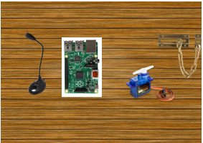
Figure 3.7 Design of Door Lock System for Prohibited Rooms


Raspberry Pi with Voice Recognition will be placed.
Figure 3.8 Installation Place

3.2.5 Test Cases

For the test cases for this project is to evaluate the functionality and sensitivity of the system and the network performance based on the GSM network. Some method will try to test the sensitivity of voice recognition. Firstly, different distance in the meter will be taken for the user to speak from voice to this system. Then, check the functionality of the system that the GSM network will be triggered when the user accesses the locked door system.
Distance(Meter) | Deliverable | Response time
0.2
0.5
1.0
2.0

Raspberry Pi with Voice Recognition will be placed.
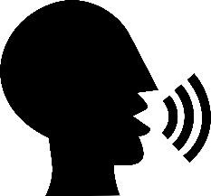

Distance

Figure 3.9 Test plan scenarios

3.3 Development Phase

In this phase which is the third phase, all assembling of hardware components and writing of the programming code will be done. There are several activities to build this defensive system as discuss earlier. The first activity is, all the hardware components will be combined together such as Raspberry Pi 2 board, GSM Module, servo motor and other parts that have been prepared to build this system.
The next activity is writing sketches. The sketches are a programming code that will control the action against the microcontroller on Raspberry Pi 2. Next, the functionality will be checked, observed and the data that have been processed will be retrieved and evaluated.

3.4 Evaluation Phase

For the evaluation phase, the door lock system with voice recognition will be evaluated based on a method that described in the previous part 3.2.5. All information or data that receive will be evaluated and analysis first to get identify the functionality of the system. Evaluation will include based on the distance, deliverables and response time.

3.5 Documentation Phase

Documentation Phase is the last phase of this research project where all information and data that have been gathered will be documented in a report. Figure 3.10, Figure 3.11, Figure 3.12, Figure 3.13 and Figure 3.14 show the summary of every phase included in this project research.

PHASE | ACTIVITIY | TECHNIQUE | OUTCOME
Initiation | Information and resource gathering such as:  - What is microcontroller?,  - Voice recognition technology,  - What types of peripherals of microcontroller should be used?,  - The objectives, research scope and significance of the project,  - The limitations of the hardware used. | Searching and reviewing of the articles and journals that have related issue and supporting information from databases, books, and websites. | Information gathered will lead to making a literature review.
Figure 3.10 Initiation Phase

This figure 3.10 show the initiation phase where all information and resources will be gathering from the articles, journal, books, database and website. Then, information that gathered will lead to a making a literature review.

PHASE | ACTIVITY | TECHNIQUE | OUTCOME
Planning | The proposed architecture for the door lock system is with designed to illustrate the architecture of the project system.  Performance of the door lock system are identified by using a test plan.  Evaluation method  List of hardware and software requirement |  | Hardware requirements:  - Raspberry Pi 2  - Power Source  - LCD Keypad Shield  - Servo Motor  Software requirements:  - Python IDE  - Raspbian OS  - Raspberry Pi Programming Language
Figure 3.11 Planning Phase

Figure 3.11 show the planning phase where the requirement is gathered to make a system that has proposed. This phase also will identified on how evaluate will be used for this project research and system.

PHASE | ACTIVITY | TECHNIQUE | OUTCOME
Development | Programming  Implement and build the door lock system | Programming code will be included in the sketch.  All hardware are attached together. | Door lock system with voice recognition for prohibited room
Figure 3.12 Development Phase

Then, in Figure 3.12 is the development phase where all information and equipment that gathered will be start to develop a system that have been proposed. It is where all hardware and programming will be attach together until this system is fully functional.

PHASE | ACTIVITY | TECHNIQUE | OUTCOME
Evaluation | Perform tests based on design specifications. | Analyze and gather observation on testing of the system. | Complete the observation on testing of the system and obtain data from test
Figure 3.13 Evaluation Phase

In this Figure 3.13 is about evaluation phase. After the development of the system is done, this system will be test and analysis to evaluate the performance and the functionality of the system. All information that have provide from analysis will be store.
PHASES | ACTIVITIES | TECHNIQUE | OUTCOME
Documentation | Conclusion and recommendations  All information of the research are combined.  Document all activities performed. |  | Complete the project report.
Figure 3.14 Documentation Phase

Lastly, in Figure 3.14 show the documentation phase where all activities during that performed in research project will be combine and documented to make a completed report.

3.6 Summary

In this chapter, every step procedure that are involved in this research project were explained. There are initiation phase, planning phase, development phase, evaluation phase and documentation phase where each phase has its own activities, outcomes and techniques. The activities are what happen in that phase. Then, technique are used to cover on how the activities can be completed while outcome describes the data, information and evaluation that gained at the end of every phase. This chapter is important because it show the flow of the project will working. Besides, it also ensures that the researcher performs the project activities on track and the developer to achieve the objectives of the project.

REFERENCES

Ahmed, Z., & Ece, B. T. (2018). Smart Home Security Using Raspberry-Pi, 4(7), 164–169.
Arora, R. (n.d.). Introduction to Microcontrollers Rajat Arora Micro-Controller.
Brown, J., Shipman, B., & Vetter, R. (2007). SMS: The short message service. Computer, 40(12), 106–110. https://doi.org/10.1109/MC.2007.440
Chandy, J. A. (2007). Microcontroller Introduction.
Churi, A. (2016). E – zip : An electronic lock for secured system, 45–49.
Dhami Himani Singh. (2017). Raspberry Pi Home Automation Using Android Application, 3, 521–525.
Guilford, B. J. (n.d.). The World of Microcontrollers : A Beginning Guide to the HC11 Microkit, 95064(831).
Iizuka, S., Tsujino, K., Oguri, S., & Furukawa, H. (2012). Speech recognition technology and applications for improving terminal functionality and service usability. NTT DOCOMO Technical Journal, 13(4), 79–84.
Kong, S., Application, F., & Data, P. (2016). DOOR LOCK SENSOR AND ALARM ( 12 ) United States Patent, 2(12), 12–15. https://doi.org/10.1016/j.(73)
Lipovski, G. J. (2007). Introduction to Microcontrollers. Introduction to Microcontrollers, 379–414. https://doi.org/10.1016/B978-012451838-4/50016-9
Memon, Y. A. L. I., Motan, I., Akbar, M. A. L. I., Hameed, S., & Hasan, M. U. L. (2016). Speech Recognition System for a Voice Controlled Robot With Real Time Obstacle Detection and. International Journal Of Electrical, Electronics And Data Communication, 4(9), 33–37.
Muda, L., Begam, M., & Elamvazuthi, I. (2010). Voice Recognition Algorithms using Mel Frequency Cepstral Coefficient (MFCC) and Dynamic Time Warping (DTW) Techniques, 2(3), 138–143. https://doi.org/10.5815/ijigsp.2016.09.03
Parab, A. S., & Amol, J. (2015). Implementation of Home Security System using GSM Module and Microcontroller. International Journal of Computer Science and Information Technologies, 6(3), 2950–2953.
Rajput, A., & Jain, A. (2015). Basic Introduction to Microcontroller and Its Features. Ankita Jain International Journal of Engineering Technology Science and Research IJETSR Www.Ijetsr.Com ISSN, 2(4), 2394–3386.
Rom, P. (2012). Microcontroller Basics Microcontroller Components, 1–46.
Singh, K., Vasant, P., Elamvazuthi, I., & Kannan, R. (2015). PID tuning of servo motor using bat algorithm. Procedia Computer Science, 60(1), 1798–1808. https://doi.org/10.1016/j.procs.2015.08.290
World of Buzz (2017). Malaysia Ranks Number 1 in South East Asia for Highest Crime Rate. Retrieved on Mar 21 2018, from https://www.worldofbuzz.com/malaysia-ranks-number- 1-south-east-asia-highest-crime-rate/
Øyvind Nydal Dahl (2014). What is a Microcontroller? - Build Electronic Circuits. Retrieved on May 6 2018, from https://www.build-electronic-circuits.com/what-is-a-microcontroller/
Truthfinder (2017). Property Crime Definition. Retrieved on May 6 2018, from https://www.truthfinder.com/glossary/property-crime-definition/
Yang, S.-M., & Lin, K.-W. (2015). Automatic Control Loop Tuning for Permanent Magnet AC Servo Motor Drives. IEEE Transactions on Industrial Electronics, 0046(c), 1–1. https://doi.org/10.1109/TIE.2015.2495300

